PROJECT TITLE

DC PANEL METER USING ARDUINO

MENTOR NAME

SAIRAM SAI KRISHNA

STUDENT NAME

SAI SRIVALLI MAJJI

ALETI SREEJA

SLESHA REDDY

INDHU SRI

ABSTRACT

The purpose of this voltmeter is that it can measure voltage passing any given

circuit or an electrical system. It is a every handy and can be used by everyone

very easily. This can be used in households also. The general purpose analog

voltmeter may have an accuracy of a few percent of full scale, and are used with

voltages from a fraction of a volt to several thousand volts. To overcome the

defects of analog voltmeters, Digital Voltmeters are introduced. Unlike analog

voltmeters, which scale and a pointer to show the measured voltage, digital

voltmeters directly display the measured voltage numerical on a digital display.

Digital voltmeters can be made with high accuracy, typically better than 1% . With

high speed measurement and option of storing the values in a memory. Specially

calibrated test instruments have higher accuracies , with laboratory instruments

capable of a few parts per million. This digital format display aids visual

convenience. They are very accurate and have high resolution. They are robust and

precise than their analog counterparts .

In this project, an Arduino based Digital Voltmeter which can measure voltages up

to 50V is designed.

WORKING

The aim of the project is to build a digital voltmeter using Arduino UNO. The components

required and the construction of the project is very simple. The working of the project is

explained here.

In a digital voltmeter, the voltages to be measured, which are in analog form, are converted to

digital form with the help of Analog to Digital Converters (ADC). Hence, the ADC feature of the

Arduino UNO is utilized in this project.

In the first circuit, which is used to measure a maximum voltage of 5V, the input voltage is given

to the analog input pin of the Arduino. The reference voltage of the ADC is 5V. The ADC in

Arduino UNO is of 10-bit resolution. Hence, the input voltage is calculated by multiplying the

analog value at the analog pin with 5 and dividing the value with 2 10  i.e. 1024.

The range of voltages for Arduino UNOs analog input is 0V to 5V. Hence, in order to increase

this range, a voltage divider circuit must be used

The rest of the calculations are made in the programming part of IT.



RESULT

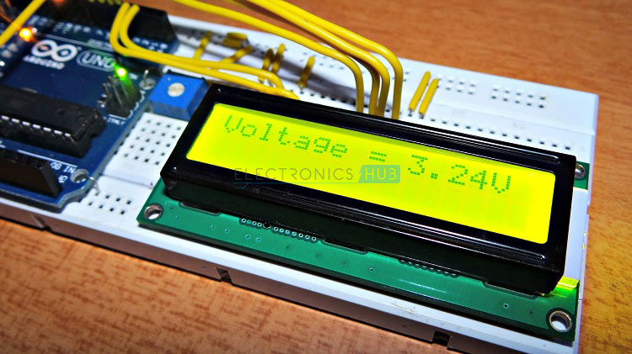

PHOTOGRAPH DURIN THE CERTIFICATION ON DIAS

